**DAILY ONLINE ACTIVITIES SUMMARY**

|  |  |  |  |  |  |  |  |  |
| --- | --- | --- | --- | --- | --- | --- | --- | --- |
| **Date:** | **23-06-2020** | | | | | **Name:** | **SHAIFA SHALA** | |
| **Sem & Sec** | **6 B** | | | | | **USN:** | **4AL17CS084** | |
| **Online Test Summary** | | | | | | | | |
| **Subject** | | **1)Java Pre-Placement Training Test**  **2) Python Application Programming Assignment Test** | | | | | | |
| **Max. Marks** | | **1)10**  **2)20** | | **Score** | | | **1)9**  **2)19** | |
| **Certification Course Summary** | | | | | | | | |
| **Course** | **1)Java and J2EE**  **2)Data Structures in C** | | | | | | | |
| **Certificate Provider** | | | **____** | | **Duration** | | | **4 Hours** |
| **Coding Challenges** | | | | | | | | |
| **Problem Statement: 1 Java Program** | | | | | | | | |
| **Status: Executed** | | | | | | | | |
| **Uploaded the report in Github** | | | | | **Yes** | | | |
| **If yes Repository name** | | | | | https://github.com/shaifashala/DailyReport.git | | | |
| **Uploaded the report in slack** | | | | | **Yes** | | | |

Online Test Details: (Attach the snapshot and briefly write the report for the same)

**Java Pre-Placement Training Test:**

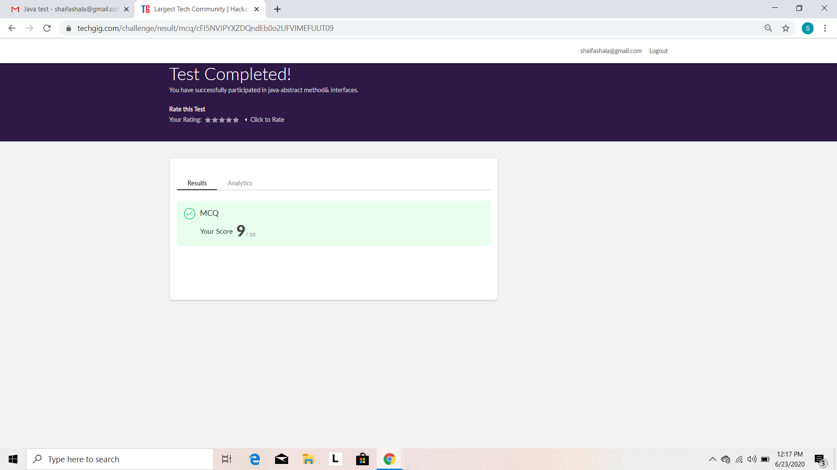

**Python Application Programming Assignment Test:**

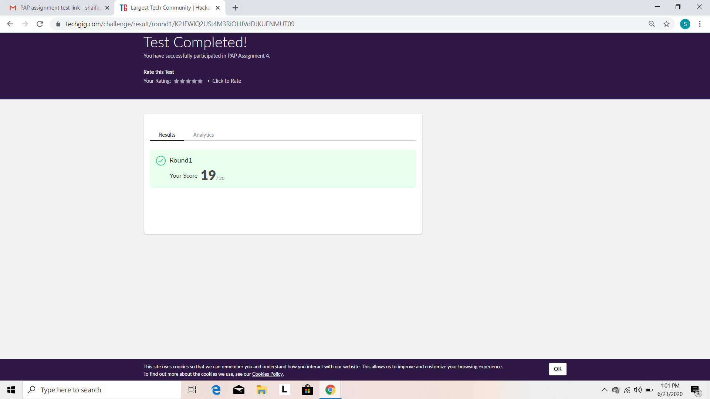

Certification Course Details: (Attach the snapshot and briefly write the report for the same)

Attended class on the topic Java and J2EE. [9:15 am to 11:00am]

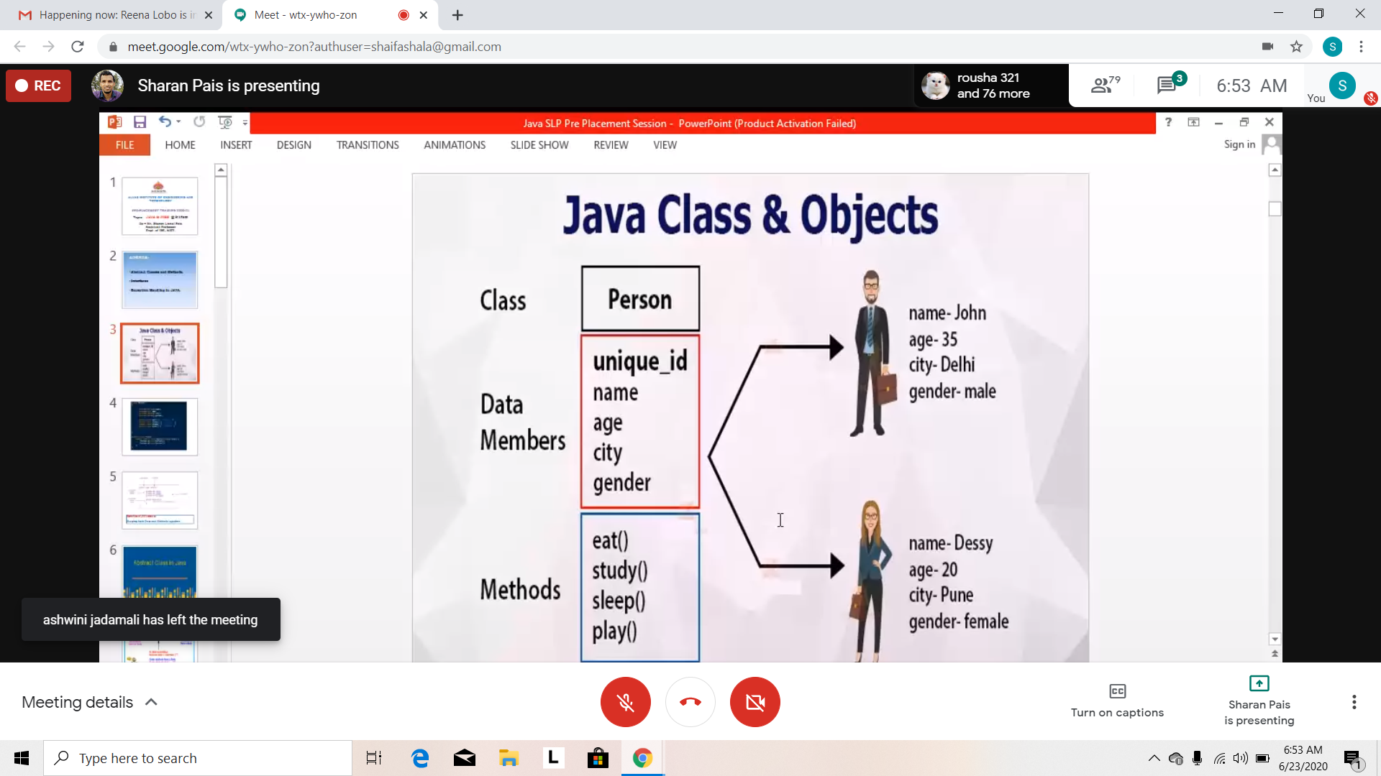

Attended class on the topic Data Structures in C. [11:00 am to 1:30pm]

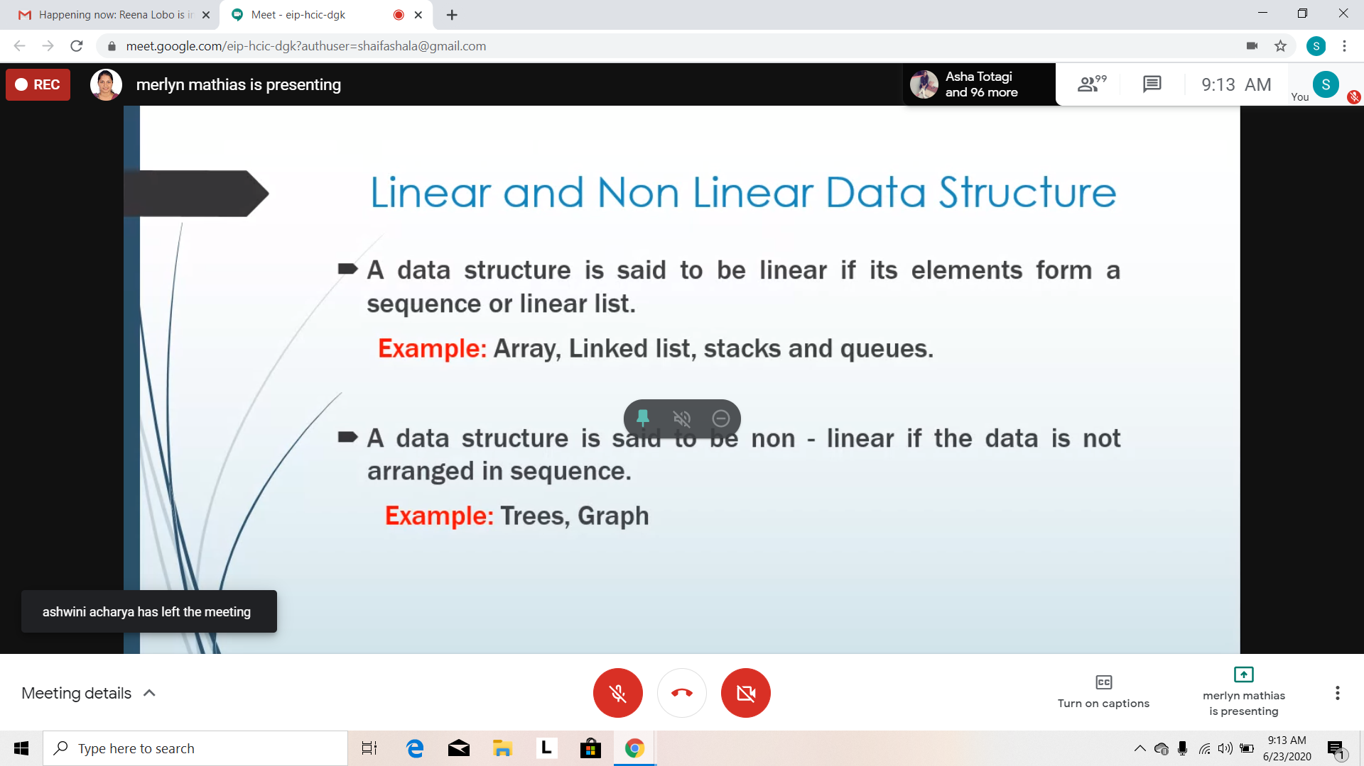

Coding Challenges Details: (Attach the snapshot and briefly write the report for the same)

Program 1:

